LIGHT PROPERTIES

**Properties of Light and the Electromagnetic Spectrum**

|  |  |
| --- | --- |
| The electromagnetic spectrum showing y-rays, ex-rays, UV, IR, microwave, WIFI, FM radio, AM waves, and long radio waves. | Since light energy and wavelength are related, analyzers can employ light from different parts of the spectrum for monitoring.  Light travels as an oscillating electromagnetic wave. |
| * Gaseous pollutants can be identified using technologies which can determine the presence or absence of certain wavelengths of light.      * The concentration of the pollutant can be measured by how much the original intensity of that wavelength of light is being reduced. | Wavelength showing amplitude and length |

* Some technologies tend to be specific to a particular gas or pollutant.
* Other technologies are used to measure a range of gases.
* Light-based analyzers typically use LED or tunable diode lasers as light sources.
* The measurement technology must be able to be calibrated to accurately measure small and large concentrations of the gas or gases being measured.
* Some analyzers have dual-ranges to accomplish this.

**Use of Planck’s Constant, Linking Frequency/ Wavelength to Energy**

**Proportionality between frequency and energy**

Examples:

* Higher ultraviolet (UV) energy can cause sunburn.
* Lower energy infrared (IR) energy from heat lamp.

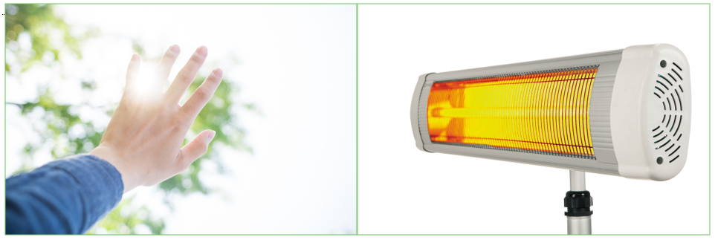

Energy = Planck’s constant x frequency of EM radiation, where h = 6.63 x 10 -27 erg-seconds

= Planck’s constant x (speed of light / wavelength of EM radiation)

E=hv=hc over λ

E=energy
h=Planck’s constant (6.63 X 10 -27 erg-seconds)
v=frequency
c=speed of light
λ =wavelength


**Transition Regions**

**The Effects of Different Energies of Electromagnetic (EM) Radiation on Molecules**

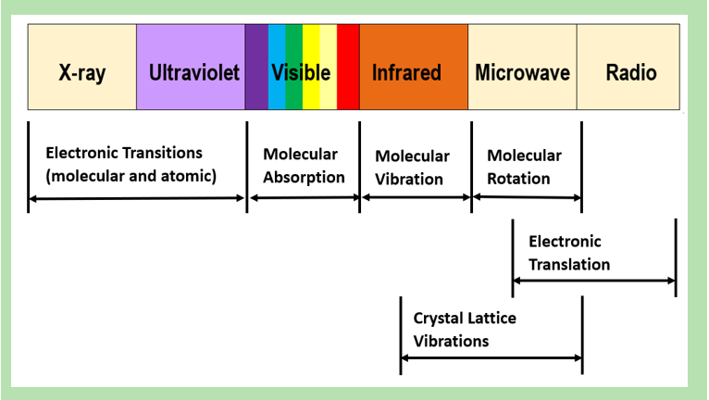

**How Light Absorption May Affect a Molecule**

**(Example: Vibration of SO2)**

The atoms and electrons in a molecule (in this case SO2) move in specific patterns at different energy states. This image below shows specific motions in SO2 when photons of the proper energy are absorbed.

Energy can be absorbed at many differentλλ.

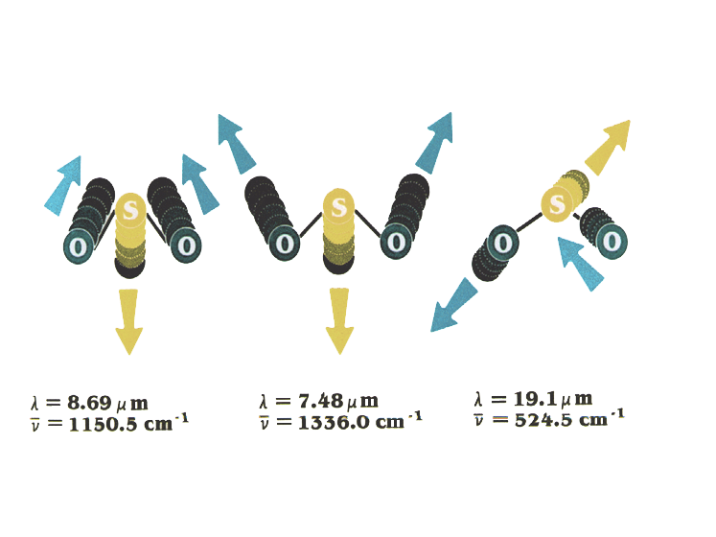

If the SO2 molecule encounters EM radiation at a frequency that corresponds to the energy necessary to take it from one energy state to another, it has a higher probability of being absorbed by the molecule.

Molecules are made up of atoms and electrons:

* Arranged in specific patterns
* Which undergo specific and complex motions

If a light of given λ should resonate with one of these motions, there is a high probability of it being absorbed by the molecule.

**Molecules Absorb Light at Specific Wavelengths**

|  |  |
| --- | --- |
| Image depicting molecules absorbing light at specific wavelengths | You can identify a particular gas or pollutant and its concentration by which wavelengths of light are absorbed, and how much of the original light intensity at that wavelength is absorbed. |

**Spectra of Different Molecules Can Overlap**

|  |  |
| --- | --- |
| Image depicting how a spectra of different molecules can overlap | Since gases will sometimes have overlapping absorbance peaks at particular wavelengths, in the case of a mix of gases, you need to use a wavelength that is specific to the one particular gas of interest. |

You want to avoid using a wavelength that is common to two or more gases in the mix, or you can get interferences in your measurements and get readings that are biased high.

**Absorbance Wavelengths for Different Gases**

The image below shows the absorbance wavelengths for different gases. You can see how at some wavelengths, more than one gas absorbs that frequency. At other wavelengths, only one gas absorbs the light.

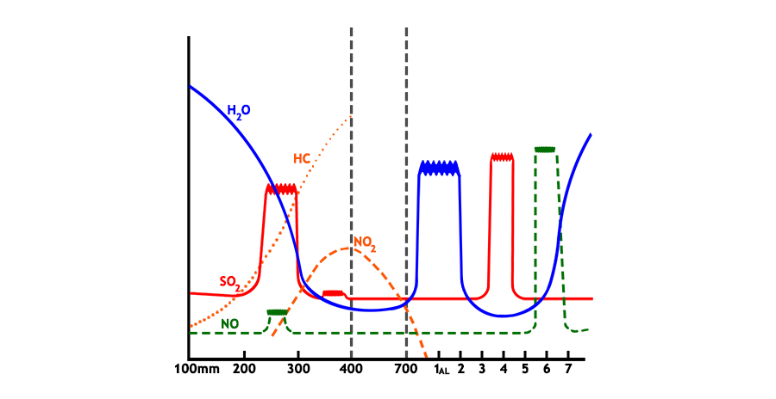

**Beer – Lambert Law**

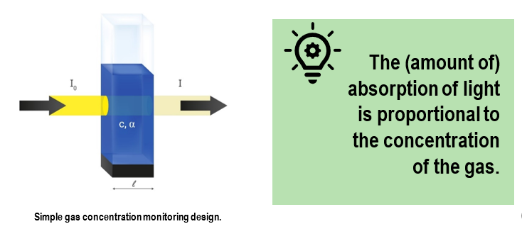

* If we TRANSMIT “light” in the stack it will be:
* Transmitted if it’s the wrong energy
* Absorbed if it’s the right energy
* If there is particulate matter (PM) present it can also be:
* Scattered
* Reflected

|  |  |
| --- | --- |
| * The transmittance of light is dependent on: * λ * Concentration * Pathlength * Properties of the pollutant molecule | Using this principle, an instrument can be designed! |

**More about Beer – Lambert’s Law**

Absorption of light is related to:

* Absorption coefficient dependencies
* Wavelength of light
* Properties of the pollutant molecule

Number of molecules in light path:

* Concentration
* Path length

The value of the absorption coefficient is dependent upon:

* λ of light
* Properties of the pollutant molecule

The coefficient expresses the degree to which a molecule will absorb light energy at a given λ.

**Beer Lambert Law**

Beer Lambert Law formula
A = absorbance
∝ = molecular absorption coefficient (dependent on wavelength)
Ɩ = path length (distance the light beam travels through the flue gas)  
c = gas concentration


**For any particular wavelength**

|  |  |
| --- | --- |
| **Calibration Plot Based on Beer-Lambert Law** | Calibration plot based on Beer-Lambert Law |

By using calibration standards of known concentration, you can calibrate the analyzer response to any gas concentration across the range of calibration.