Storage Pile Wind Erosion

9.1 Characterization of Source Emissions 9-1
9.2 Emission Estimation: Primary Methodology 9-2
9.3 Emission Estimation: Alternate Methodology 9-8
9.4 Demonstrated Control Techniques 9-8
9.5 Regulatory Formats 9-9
9.6 Compliance Tools 9-9
9.7 Sample Cost-Effectiveness Calculation 9-11
9.8 References 9-14

Characterization of Source Emissions

Dust emissions may be generated by wind erosion of open areas of exposed soils or other aggregate materials within an industrial facility. These sources typically are characterized by nonhomogeneous surfaces impregnated with nonerodible elements (particles larger than approximately 1 centimeter [cm] in diameter). Field testing of coal piles and other exposed materials using a portable wind tunnel has shown that: (a) threshold wind speeds exceed 5 meters per second (m/s) (11 miles per hour [mph]) at 15 cm above the surface or 10 m/s (22 mph) at 7 m above the surface, and (b) particulate emission rates tend to decay rapidly (half-life of a few minutes) during an erosion event. In other words, these aggregate material surfaces are characterized by finite availability of erodible material (mass/area) referred to as the erosion potential. Any natural crusting of the surface binds the erodible material, thereby reducing the erosion potential. Loose soils or other aggregate materials consisting of sand-sized materials act as an unlimited reservoir of erodible material and can sustain emissions for periods of hours without substantial decreases in emission rates.

If typical values for threshold wind speed at 15 cm are corrected to typical wind sensor height (7 to 10 m), the resulting values exceed the upper extremes of hourly mean wind speeds observed in most areas of the country. In other words, mean atmospheric wind speeds are not sufficient to sustain wind erosion from flat surfaces of the type tested. However, wind gusts may quickly deplete a substantial portion of the erosion potential. Because erosion potential has been found to increase rapidly with increasing wind speed, estimated emissions should be related to the gusts of highest magnitude. The routinely measured meteorological variable that best reflects the magnitude of wind gusts is the fastest mile. This quantity represents the wind speed corresponding to the whole mile of wind movement that has passed by the 1 mile contact anemometer in the least amount of time. Daily measurements of the fastest mile are presented in the monthly Local Climatological Data (LCD) summaries. The duration of the fastest mile, typically about 2 minutes (for a fastest mile of 30 mph), matches well with the half-life of the erosion process, which ranges between 1 and 4 minutes. It should be noted, however, that peak winds can significantly exceed the daily fastest mile.

The wind speed profile in the surface boundary layer is found to follow a logarithmic distribution as follows:
$u(z) = \frac{\text{u*}}{0\text{.}4} \text{ln} \frac{z}{z_{0}} (z > z_{0})$
(1)

where,
u = wind speed (cm/s)
u* = friction velocity (cm/s)
z = height above test surface (cm)
z_{o} = roughness height (cm)
0.4 = von Karman’s constant (dimensionless)

The friction velocity (u*) is a measure of wind shear stress on the erodible surface, as determined from the slope of the logarithmic velocity profile. The roughness height (z_{o}) is a measure of the roughness of the exposed surface as determined from the y-intercept of the velocity profile, i.e., the height at which the wind speed is zero. These parameters are illustrated in Figure 9-1 for a roughness height of 0.1 cm.
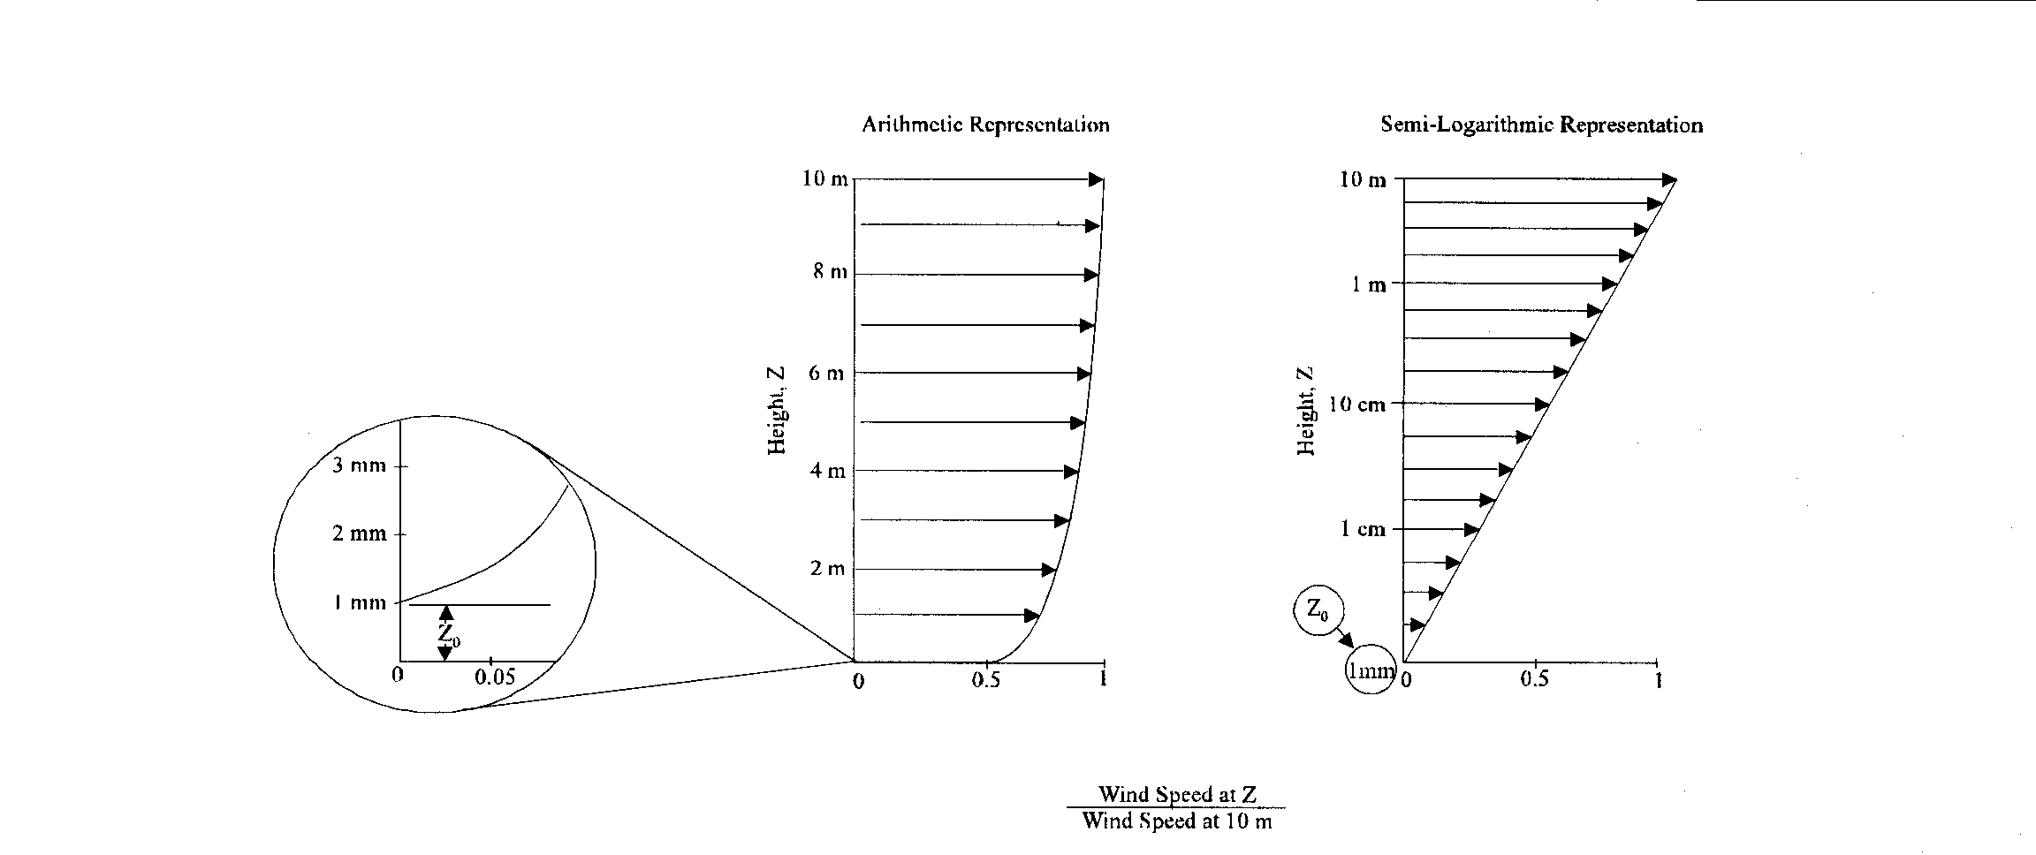

Figure 9-1. Illustration of Logarithmic Wind Velocity Profile

Emissions generated by wind erosion are also dependent on the frequency of disturbance of the erodible surface because each time that a surface is disturbed, its erosion potential is restored. A disturbance is defined as an action that results in the exposure of fresh surface material. On a storage pile, this would occur whenever aggregate material is either added to or removed from the old surface. A disturbance of an exposed area may also result from the turning of surface material to a depth exceeding the size of the largest pieces of material present.

Emission Estimation: Primary Methodology ¹⁻¹¹

This section was adapted from Section 13.2.5 of EPA’s Compilation of Air Pollutant Emission Factors (AP-42). Section 13.2.5 was last updated in January 1995.

The PM10 emission factor for wind-generated particulate emissions from mixtures of erodible and nonerodible surface material subject to disturbance may be expressed in units of grams per square meter (g/m²) per year as follows:
$\text{PM10 Emission Factor }=\text{ 0}\text{.}5 \sum_{i=1}^{N}{}P_{i}$
( 2 )

where,
N = number of disturbances per year
Pi = erosion potential corresponding to the observed (or probable) fastest mile of wind for the ith period between disturbances (g/m²)

In calculating emission factors, each area of an erodible surface that is subject to a different frequency of disturbance should be treated separately. For a surface disturbed daily, N = 365 per year, and for a surface disturbance once every 6 months, N = 2 per year. The erosion potential function for a dry, exposed surface is given as:
P = 58 (u* - u_{t}*)² + 25 (u* - u_{t}*) ( 3 )
P = 0 for u* ≤ u_{t}*

where,
u* = friction velocity (m/s)
u_{t} = threshold friction velocity (m/s)

Because of the nonlinear form of the erosion potential function, each erosion event must be treated separately. The PM2.5/PM10 ratio for windblown fugitive dust posted on EPA’s CHIEF website is 0.15 based on the analysis conducted by MRI on behalf of WRAP.¹¹

Equations 2 and 3 apply only to dry, exposed materials with limited erosion potential. The resulting calculation is valid only for a time period as long or longer than the period between disturbances. Calculated emissions represent intermittent events and should not be input directly into dispersion models that assume steady-state emission rates. For uncrusted surfaces, the threshold friction velocity is best estimated from the dry aggregate structure of the soil. A simple hand sieving test of surface soil can be used to determine the mode of the surface aggregate size distribution by inspection of relative sieve catch amounts, following the procedure described below.

FIELD PROCEDURE FOR DETERMINING THRESHOLD FRICTION VELOCITY
(from a 1952 laboratory procedure published by W. S. Chepil⁵)

Step 1. Prepare a nest of sieves with the following openings: 4 mm, 2 mm, 1 mm, 0.5 mm, and 0.25 mm. Place a collector pan below the bottom (0.25 mm) sieve.
Step 2. Collect a sample representing the surface layer of loose particles (approximately 1 cm in depth, for an encrusted surface), removing any rocks larger than about 1 cm in average physical diameter. The area to be sampled should be not less than 30 cm by 30 cm.
Step 3. Pour the sample into the top sieve (4-mm opening), and place a lid on the top.
Step 4. Move the covered sieve/pan unit by hand, using a broad circular arm motion in the horizontal plane. Complete 20 circular movements at a speed just necessary to achieve some relative horizontal motion between the sieve and the particles.
Step 5. Inspect the relative quantities of catch within each sieve, and determine where the mode in the aggregate size distribution lies, i.e., between the opening size of the sieve with the largest catch and the opening size of the next largest sieve.
Step 6. Determine the threshold friction velocity from Table 9-1.

The results of the sieving can be interpreted using Table 9-1. Alternatively, the threshold friction velocity for erosion can be determined from the mode of the aggregate size distribution using the graphical relationship described by Gillette.^{5, 6} If the surface material contains nonerodible elements that are too large to include in the sieving (i.e., greater than about 1 cm in diameter), the effect of the elements must be taken into account by increasing the threshold friction velocity.¹⁰

Table 9-1. Field Procedure for Determination of Threshold Friction Velocity (Metric Units)
Tyler Sieve No. | Opening (mm) | Midpoint (mm) | u_{t}* (cm/s)
5 | 4
9 | 2 | 3 | 100
16 | 1 | 1.5 | 76
32 | 0.5 | 0.75 | 58
60 | 0.25 | 0.375 | 43

Threshold friction velocities for several surface types have been determined by field measurements with a portable wind tunnel. These values are presented in Table 9-2.

Table 9-2 Threshold Friction Velocities (Metric Units)
Material | Threshold  friction  velocity (m/s) | Roughness  height (cm) | Threshold wind velocity at  10 m (m/s)
Material | Threshold  friction  velocity (m/s) | Roughness  height (cm) | z_{o} = Actual | z_{o} = 0.5 cm
Overburdenª | 1.02 | 0.3 | 21 | 19
Scoria (roadbed material)ª | 1.33 | 0.3 | 27 | 25
Ground coal (surrounding coal pile)ª | 0.55 | 0.01 | 16 | 10
Uncrusted coal pileª | 1.12 | 0.3 | 23 | 21
Scraper tracks on coal pile^{a,b} | 0.62 | 0.06 | 15 | 12
Fine coal dust on concrete pad^{c} | 0.54 | 0.2 | 11 | 10
ª Western surface coal mine; reference 2.
^{b} Lightly crusted.
^{c} Eastern power plant; reference 3.

The fastest mile of wind for the periods between disturbances may be obtained from the monthly local climatological data (LCD) summaries for the nearest reporting weather station that is representative of the site in question.⁷ These summaries report actual fastest mile values for each day of a given month. Because the erosion potential is a highly nonlinear function of the fastest mile, mean values of the fastest mile are inappropriate. The anemometer heights of reporting weather stations are found in Reference 8, and should be corrected to a 10-m reference height using Equation 1. To convert the fastest mile of wind (u⁺) from a reference anemometer height of 10 m to the equivalent friction velocity (u*), the logarithmic wind speed profile may be used to yield the following equation:

u* = 0.053 u₁₀⁺ (4)

where,
${}_{\text{10}}^{+}$ u* = friction velocity (m/s)
u = fastest mile of reference anemometer for period between disturbances (m/s)

This assumes a typical roughness height of 0.5 cm for open terrain. Equation 4 is restricted to large relatively flat exposed areas with little penetration into the surface wind layer.

If the pile significantly penetrates the surface wind layer (i.e., with a height-to-base ratio exceeding 0.2), it is necessary to divide the pile area into subareas representing different degrees of exposure to wind. The results of physical modeling show that the frontal face of an elevated pile is exposed to wind speeds of the same order as the approach wind speed at the top of the pile.

For two representative pile shapes (conical and oval with flattop, 37-degree side slope), the ratios of surface wind speed (u_{s}) to approach wind speed (u_{r}) have been derived from wind tunnel studies.⁹ The results are shown in Figure 9-2 corresponding to an actual pile height of 11 m, a reference (upwind) anemometer height of 10 m, and a pile surface roughness height (z_{o}) of 0.5 cm. The measured surface winds correspond to a height of 25 cm above the surface. The area fraction within each contour pair is specified in Table 9-3.

Table 9-3. Subarea Distribution for Regimes of u_{s}/u_{r}
Pile subarea | Percent of pile surface area
Pile subarea | Pile A | Pile B1 | Pile B2 | Pile B3
0.2a | 5 | 5 | 3 | 3
0.2b | 35 | 2 | 28 | 25
0.2c | NA | 29 | NA | NA
0.6a | 48 | 26 | 29 | 28
0.6b | NA | 24 | 22 | 26
0.9 | 12 | 14 | 15 | 14
1.1 | NA | NA | 3 | 4
NA = not applicable.

The profiles of u_{s}/u_{r} in Figure 9-2 can be used to estimate the surface friction velocity distribution around similarly shaped piles, using the following procedure:

$u_{\text{10}}^{+} = u^{+} \frac{\text{ln} (\text{10/0}\text{.}\text{005})}{\text{ln} (\text{z/0}\text{.}\text{005})}$Step 1. Correct the fastest mile value (u⁺) for the period of interest from the anemometer height (z) to a reference height of 10 m (u${}_{\text{10}}^{+}$) using a variation of Equation 1:

( 5 )

where a typical roughness height (z_{o}) of 0.5 cm (0.005 m) has been assumed. If a site-specific roughness height is available, it should be used.

${}_{s}^{+}$$u_{s}^{+} = \frac{ (u_{s})}{u_{r}} u_{\text{10}}^{+}$Step 2. Use the appropriate part of Figure 9-2 based on the pile shape and orientation to the fastest mile of wind, to obtain the corresponding surface wind speed distribution (u ):

( 6 )

Step 3. For any subarea of the pile surface having a narrow range of surface wind speed, use a variation of Equation 1 to calculate the equivalent friction velocity (u*): u* = (0.4 u⁺_{s}) / ln (25 / 0.5) = 0.10 u⁺_{s} ( 7 )

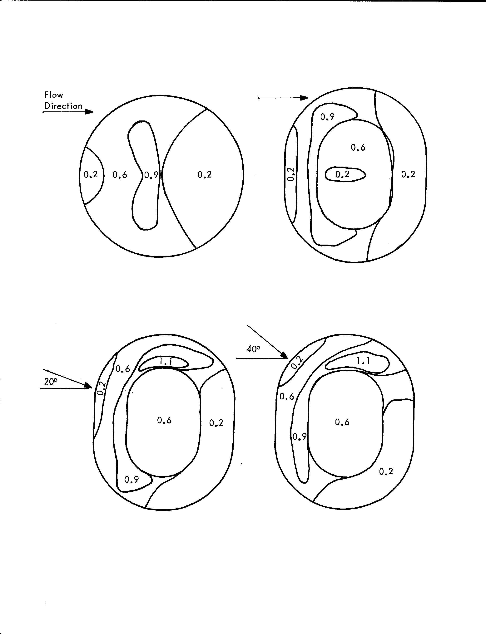

Pile A
Pile B1

Pile B2
Pile B3

Figure 9-2. Contours of Normalized Surface Wind Speed Ratios, u_{s}/u_{r}
From this point on, the procedure is identical to that used for a flat pile, as described above. Implementation of the above procedure is carried out in the following steps:

Step 1. Determine threshold friction velocity for erodible material of interest (see Table 9-2 or determine from mode of aggregate size distribution).
Step 2. Divide the exposed surface area into subareas of constant frequency of disturbance (N).
Step 3. Tabulate fastest mile values (u⁺) for each frequency of disturbance and correct them to 10 m (u${}_{\text{10}}^{+}$) using Equation 5.
Step 4. Convert fastest mile values (u₁₀) to equivalent friction velocities (u*), taking into account (a) the uniform wind exposure of nonelevated surfaces, using Equation 4, or (b) the nonuniform wind exposure of elevated surfaces (piles), using Equations 6 and 7.
Step 5. For elevated surfaces (piles), subdivide areas of constant N into subareas of constant u* (i.e., within the isopleth values of u_{s}/u_{r} in Figure 9-2 and Table 9-3) and determine the size of each subarea.
Step 6. Treating each subarea (of constant N and u*) as a separate source, calculate the erosion potential (P_{i}) for each period between disturbances using Equation 3 and the emission factor using Equation 2.
Step 7. Multiply the resulting emission factor for each subarea by the size of the subarea, and add the emission contributions of all subareas. Note that the highest 24-hour emissions would be expected to occur on the windiest day of the year. Maximum emissions are calculated assuming a single event with the highest fastest mile value for the annual period.
The recommended emission factor equation presented above assumes that all of the erosion potential corresponding to the fastest mile of wind is lost during the period between disturbances. Because the fastest mile event typically lasts only about 2 minutes, which corresponds roughly to the half-life for the decay of actual erosion potential, it could be argued that the emission factor overestimates particulate emissions. However, there are other aspects of the wind erosion process that offset this apparent conservatism as follows:

- The fastest mile event contains peak winds that substantially exceed the mean value for the event.
- Whenever the fastest mile event occurs, there are usually a number of periods of slightly lower mean wind speed that contain peak gusts of the same order as the fastest mile wind speed.

Of greater concern is the likelihood of over prediction of wind erosion emissions in the case of surfaces disturbed infrequently in comparison to the rate of crust formation.

Emission Estimation: Alternate Methodology

EPA published a total suspended particulate (TSP) emission factor equation for wind erosion of active storage piles in 1989 that is not included in AP-42.¹² For days when there was at least 0.01 inch of precipitation, the TSP emissions were zero. The TSP emission factor equation (in units of lb/day/acre of surface) for days when there was less than 0.01 inch of precipitation was given as:

E_{TSP} = 1.7 (s/1.5) (f/15)
where, s = silt content of material (weight %)
f = percentage of time the unobstructed wind speed is greater than 12 mph at the mean pile height

The annual TSP emissions factor equation for wind blown dust from active storage piles was given as follows:

TSP (lb/year/acre of surface) = 1.7 (s/1.5) (365 [365-p] / 235) (f/15)

where, s = silt content of material (weight %)
p = number of days per year with at least 0.01 inch of precipitation
f = percentage of time the unobstructed wind speed is greater than 12 mph at the mean pile height

Based on the PM10/TSP ratio of 0.5 for wind blown dust from active storage piles published in Section 13.2.5 of AP-42 and a PM2.5/PM10 ratio of 0.15 for wind blown dust¹¹, the PM10 and PM2.5 emission factor equations (in units of lb/day/acre) would be:

E_{PM10} = 0.85 (s/1.5) (f/15)
E_{PM2.5} = 0.13 (s/1.5) (f/15)

The short-term hourly TSP emission factor equation for wind blown dust from active storage piles (in units lb/acre-hour) given in the 1989 EPA report was equal to the wind speed (in units of mph) multiplied by a factor of 0.72. Thus for a wind speed that averaged 25 mph during a one-hour period, the TSP emission factor during that hour would be 18 lb/acre which is equal to 2.02 g/m². The corresponding PM10 and PM2.5 emission factors would be 1.01 g/m² and 0.15 g/m², respectively.

Demonstrated Control Techniques

Control measures for storage pile wind erosion are designed to stabilize the erodible surface (e.g., by increasing the moisture content of the aggregate material being stored) or to shield it from the ambient wind. Table 9-4 presents a summary of control measures and reported control efficiencies for storage pile wind erosion.

Table 9-4. Control Efficiencies for Control Measures for Storage Pile Wind Erosion
Control measure | PM10 control efficiency | References/comments
Require construction of 3-sided enclosures with 50% porosity | 75% | Sierra Research, 2003.¹³ Determined through modeling of open area windblown emissions with 50% reduction in wind speed and assuming no emission reduction when winds approach open side
Water the storage pile by hand or apply cover when wind events are declared | 90% | Fitz et al., April 2000.¹⁴

Regulatory Formats

Fugitive dust control options have been embedded in many regulations for state and local agencies in the WRAP region. Regulatory formats specify the threshold source size that triggers the need for control application. Example regulatory formats for several local air quality agencies in the WRAP region are presented in Table 9-5. The website addresses for obtaining information on fugitive dust regulations for local air quality districts within California, for Clark County, NV, and for Maricopa County, AZ, are as follows:
• Districts within California: www.arb.ca.gov/drdb/drdb.htm
• Clark County, NV: www.co.clark.nv.us/air_quality/regs.htm
• Maricopa County, AZ: http://www.maricopa.gov/envsvc/air/ruledesc.asp
(Note: The Clark County website did not include regulatory language specific to storage pile wind erosion at the time this chapter was written.)

Compliance Tools

Compliance tools assure that the regulatory requirements, including application of dust controls, are being followed. Three major categories of compliance tools are discussed below.

Record keeping: A compliance plan is typically specified in local air quality rules and mandates record keeping of source operation and compliance activities by the source owner/operator. The plan includes a description of how a source proposes to comply with all applicable requirements, log sheets for daily dust control, and schedules for compliance activities and submittal of progress reports to the air quality agency. The purpose of a compliance plan is to provide a consistent reasonable process for documenting air quality violations, notifying alleged violators, and initiating enforcement action to ensure that violations are addressed in a timely and appropriate manner.

Site inspection: This activity includes (1) review of compliance records, (2) proximate inspections (sampling and analysis of source material), and (3) general observations. An inspector can use photography to document compliance with an air quality regulation.

Table 9-5. Example Regulatory Formats for Storage Pile Wind Erosion

Control Measure | Goal | Threshold | Agency
Establishes wind barrier and watering or stabilization requirements and bulk materials must be stored according to stabilization definition and outdoor materials covered | Limit visible dust emissions to 20% opacity |  | SJVAPCD  Rule 8031  11/15/2001
Best available control measures: wind sheltering, watering, chemical stabilizers, altering load-in/load-out procedures, or coverings | Prohibits visible dust emissions beyond property line and limits upwind/downwind PM10 differential to 50 ug/m3 |  | SCAQMD  Rule 403  12/11/1998
Watering, dust suppressant (when loading, stacking, etc.); cover with tarp, watering (when not loading, etc.); wind barriers, silos, enclosures, etc. | Limit VDE to 20% opacity; stabilize soil | For storage piles with >5% silt content, 3ft high, >150 sq ft; work practices for stacking, loading, unloading, and when inactive; soil moisture content min 12%; or at least 70% min for optimum soil moisture content; 3 sided enclosures, at least equal to pile in length, same for height, porosity <50% | Maricopa County  Rule 310  04/07/2004
Utilization of dust suppressants other than water when necessary; prewater; empty loader bucket slowly | Prevent wind erosion from piles; stabilize condition where equip and vehicles op | Bulk material handling for stacking, loading, and unloading; for haul trucks and areas where equipment op | Maricopa County  Rule 310  04/07/2004

On-site monitoring: EPA has stated that “An enforceable regulation must also contain test procedures in order to determine whether sources are in compliance.” Monitoring can include observation of visible plume opacity, surface testing for crust strength and moisture content, and other means for assuring that specified controls are in place.

Table 9-6 summarizes the compliance tools that are applicable to wind erosion from material storage piles.

Table 9-6. Compliance Tools for Storage Pile Wind Erosion
Record keeping | Site inspection/monitoring
Site map; work practices, including pile formation and removal times (throughputs); locations, sizes, and shapes of storage piles; moisture and silt contents of pile surface material; location/heights/densities of vegetation or other wind breaks, including maintenance times; dust suppression equipment and maintenance records; frequencies, amounts, times, and rates of watering or dust suppressant application; meteorological log. | Sampling and analysis of storage pile surface material for silt and moisture contents; observation of pile formation and removal, including wet suppression systems; observation of vehicle/ equipment operation and disturbance areas; inspection of wind sheltering including enclosures; real-time portable monitoring of PM; observation of dust plume opacity exceeding a standard.

Sample Cost-Effectiveness Calculation

This section is intended to demonstrate how to select a cost-effective control measure for fugitive dust originating from storage pile wind erosion. A sample cost-effectiveness calculation is presented below for a specific control measure (3-sided enclosure) to illustrate the procedure. The sample calculation includes the entire series of steps for estimating uncontrolled emissions (with correction parameters and source extent), controlled emissions, emission reductions, control costs, and control cost-effectiveness values for PM10 and PM2.5. In selecting the most advantageous control measure for storage pile wind erosion, the same procedure is used to evaluate each candidate control measure (utilizing the control measure specific control efficiency and cost data), and the control measure with the most favorable cost-effectiveness and feasibility characteristics is identified.

Sample Calculation for Storage Pile Wind Erosion

Step 1. Determine source activity and control application parameters.

Frequency of disturbance (days/yr) | 365
Height of pile (m) | 11
Base diameter (m) | 29.2
Total surface area (m²) | 838
Portion of pile exposed to high winds (%) | 12
Surface area exposed to high winds (m²) | 101
Threshold friction velocity u*_{t} (m/s) | 0.85

Control Measure | 3-sided enclosure
Economic Life of Control System (yr) | 10
Control Efficiency (%) | 74.7
Reference for Control Efficiency | Sierra Research, 2003¹³

The pile size, source activity parameters and control measure parameters are assumed values for illustrative purposes. A 3-sided enclosure has been chosen as the applied control measure. The control efficiency is provided by Sierra Research.¹³

The pile surface area within each surface wind speed range (see AP-42, Section 13.2.5) is as follows:

Surface areas within each wind speed range
Area ID | u_{s} / u_{r} | Pile surface
Area ID | u_{s} / u_{r} | % | Area (m²)
A | 0.9 | 12 | 101
B | 0.6 | 48 | 402
C | 0.2 | 40 | 335
Total Area |  |  | 838

Step 2. Obtain PM10 Emission Factor.
The PM10 emission factor is obtained from AP-42: PM10 EF = $\text{ 0}\text{.}5 \sum_{i=1}^{N}{}P_{i}$

P—erosion potential (g/m²) | P = 58 (u*-u*_{t})² + 25 (u*-u*_{t})
P—erosion potential (g/m²) | P = 0 for u* ≤ u_{t}*

Step 3. Calculate Uncontrolled PM Emissions. The PM10 emission factor (given in Step 2) is applied to each day for which the peak wind exceeds the threshold velocity for wind erosion. The following monthly climatic data are used for illustrative purposes and are assumed to apply to each month of the year.

Monthly erosion potential (P)
Day  of month | Peak wind (u⁺₁₀) |  | u⁺_{s (m/s)}
Day  of month | mph | m/s | Area C  u_{s} / u_{r}: 0.2 | Area B  u_{s} / u_{r}: 0.6 | Area A  u_{s} / u_{r}: 0.9
6 | 29 | 13.0 | 2.59 | 7.78 | 11.67
7 | 30 | 13.4 | 2.68 | 8.05 | 12.07
11 | 38 | 17.0 | 3.40 | 10.19 | 15.29
22 | 25 | 11.2 | 2.24 | 6.71 | 10.06
28 | 45 | 20.1 | 4.02 | 12.07 | 18.10

Monthly erosion potential (P)ª
Day  of month | u* (m/s) |  |  | P (g/m²)
Day  of month | Area C | Area B | Area A | Area C | Area B | Area A
6 | 0.26 | 0.78 | 1.17 | 0 | 0 | 13.74
7 | 0.27 | 0.80 | 1.21 | 0 | 0 | 16.32
11 | 0.34 | 1.02 | 1.53 | 0 | 5.89 | 43.70
22 | 0.22 | 0.67 | 1.01 | 0 | 0 | 5.30
28 | 0.40 | 1.21 | 1.81 | 0 | 16.32 | 77.52
 | Sum of P (g/m²) |  |  | 0 | 22.21 | 156.57
 | Area (m²) |  |  | 335 | 402 | 101
 | Monthly PM10 emissions (g) ^{b} |  |  | 0 | 4,464 | 7,907
ª Assumed to apply to 12 months of the year.
^{b} Monthly PM10 emissions = 0.5 times monthly erosion potential times surface area for each area of the pile.

The annual PM10 emissions in units of tons for each section of the pile is equal to 12 times the monthly PM10 emissions for each section of the pile divided by 454 g/lb and 2,000 lb/ton as follows:

Annual PM10 emissions for Area A = (12 x 7,907) / (454 x 2,000) = 0.104 tons
Annual PM10 emissions for Area B = (12 x 4,464) / (454 x 2,000) = 0.059 tons
Annual PM10 emissions for Area C = 0 tons
Annual PM10 emissions for storage pile = 0.104 + 0.059 + 0 = 0.163 tons

Annual PM2.5 Emissions = 0.15 x PM10 Emissions¹¹ = 0.15 x 0.163 = 0.025 tons

Step 4. Calculate Controlled PM Emissions. The controlled PM emissions (i.e., the PM emissions remaining after control) are equal to the uncontrolled emissions (calculated above in Step 3) multiplied by the percentage that uncontrolled emissions are reduced, as follows:

Controlled emissions = Uncontrolled emissions x (1 – Control Efficiency)

For this example we have selected a 3-sided enclosure as our control measure with a control efficiency of 74.7% Thus, the annual controlled PM10 and PM2.5 emissions estimates are calculated to be:

Annual Controlled PM10 emissions = (0.163 tons/yr) x (1 – 0.747) = 0.041 tons
Annual Controlled PM2.5 emissions = (0.025 tons/yr) x (1 – 0.747) = 0.006 tons

Step 5. Determine Annual Cost to Control PM Emissions.

Capital costs ($) | 2,000
Annual Operating/Maintenance costs ($) | 400
Annual Interest Rate | 3%
Capital Recovery Factor | 0.1172
Annualized Cost ($/yr) | 634

The Capital costs, Annual Operating/Maintenance (O & M) costs and Annual Interest Rate (AIR) are assumed values for illustrative purposes.

The Capital Recovery Factor (CRF) is calculated as follows:

Capital Recovery Factor = AIR x (1 + AIR) ^{Economic life} / (1 + AIR)^{Economic life} – 1

Capital Recovery Factor = 3% x (1 + 3%)¹⁰ / (1 + 3%)¹⁰ – 1 = 0.1172

The Annualized Cost is calculated by adding the product of the Capital Recovery Factor and the Capital costs to the annual O & M costs as follows:

Annualized Cost = (CRF x Capital costs) + O & M costs
Annualized Cost = (0.1172 x 2,000) + $400 = $634

Step 6. Calculate Cost Effectiveness. Cost effectiveness is calculated by dividing the annualized cost by the emissions reduction. The emissions reduction is determined by subtracting the controlled emissions from the uncontrolled emissions:

Cost effectiveness = Annualized Cost/(Uncontrolled emissions – Controlled emissions)

Cost effectiveness for PM10 emissions = $634 / (0.163 – 0.041) = $5,195/ton
Cost effectiveness for PM2.5 emissions = $634 / (0.025 – 0.006) = $34,635/ton

References

1. Cowherd, C. Jr., 1983. A New Approach to Estimating Wind Generated Emissions from Coal Storage Piles, paper presented at the APCA Specialty Conference on Fugitive Dust Issues in the Coal Use Cycle, Pittsburgh, PA, April.

2. Axtell, K., Cowherd, C. Jr., 1984. Improved Emission Factors for Fugitive Dust from Surface Coal Mining Sources, EPA-600/7-84-048, U.S. EPA, Cincinnati, OH, March.

3. Muleski, G.E., 1985. Coal Yard Wind Erosion Measurement, Midwest Research Institute, Kansas City, MO, March 1985.

4. MRI, 1988. Update of Fugitive Dust Emissions Factors in AP-42 Section 11.2-Wind Erosion, Midwest Research Institute, Kansas City, MO.

5. Chepil, W.S., 1952. Improved Rotary Sieve for Measuring State and Stability of Dry Soil Structure, Soil Science Society of America Proceedings, 16:113-117.

6. Gillette, D.A., et al., 1980. Threshold Velocities for Input of Soil Particles into the Air by Desert Soils, Journal Of Geophysical Research, 85(C10):5621-5630.

7. Local Climatological Data, National Climatic Center, Asheville, NC.

8. Changery, M.J., 1978. National Wind Data Index Final Report, HCO/T1041-01 UC-60, National Climatic Center, Asheville, NC, December.

9. Billings-Stunder, .J.B., Arya, S.P.S., 1988. Windbreak Effectiveness for Storage Pile Fugitive Dust Control: A Wind Tunnel Study, J. APCA, 38:135-143.

10. Cowherd, C. Jr., et al., 1988. Control of Open Fugitive Dust Sources, EPA 450/3-88-008, Research Triangle Park, NC, September.

11. MRI, 2006. Background Document for Revisions to Fine Fraction Ratios Used for AP-42 Fugitive Emission Factors, report prepared for the WRAP by Midwest Research Institute, Project No. 110397, February 1.

12. USEPA, 1989. Air/Superfund National Technical Guidance Study Series; Volume III – Estimation of Air Emissions from Cleanup Activities at Superfund Sites, Interim final report EPA-450/1-89-003, January.

13. Sierra Research, 2003. Final BACM Technological and Economic Feasibility Analysis, report prepared for the San Joaquin Valley Unified Air Pollution Control District, March 21.

14. Fitz, D., K. Bumiller, 2000. Evaluation of Watering to Control Dust in High Winds, J.AWMA, April.

