**How to Create a Multivalued Field**

Open the database by clicking the Microsoft Office Button, then Open and select the database to open. In the Navigation Pane, double click the table in which you want to create a multivalued field.

Now, on the Datasheet tab, go to the Fields & Columns group and click on Lookup Column.

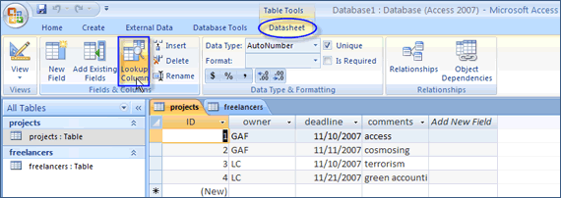  
*Figure 3 Lookup Column*

This will open the LookUp Wizard.

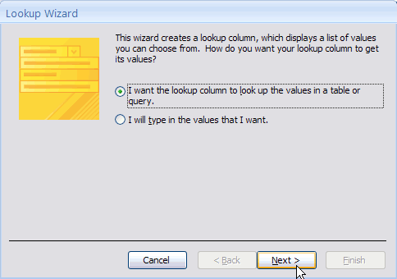  
*Figure 4 First Step in LookUp Wizard*

Choose to lookup the values in table or query –the most used option- or to type the list of values you need to use, then choose the table/query where to get the information from.

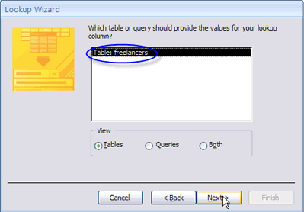  
*Figure 5 Choose the table/query*

Now, choose the fields from the table/query that you need to use.

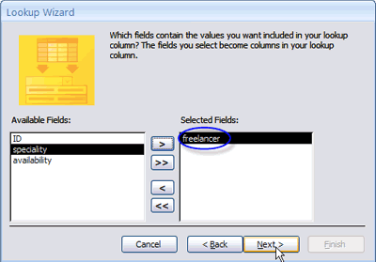  
*Figure 6 Choose the fields*

Pay attention to the last step, when you need to tick "Allow Multiple Values" for the new lookup column you have created. Otherwise, you won’t be able to use the multivalued field.

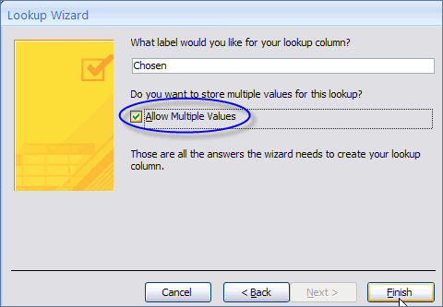  
*Figure 7 Choose to allow multiple values*

The same Lookup Wizard can be used to create a multivalued field directly from Design View when editing a table. In Design View, type the Field Name and choose Lookup Wizard in the Data Type column. The result is the same as before.

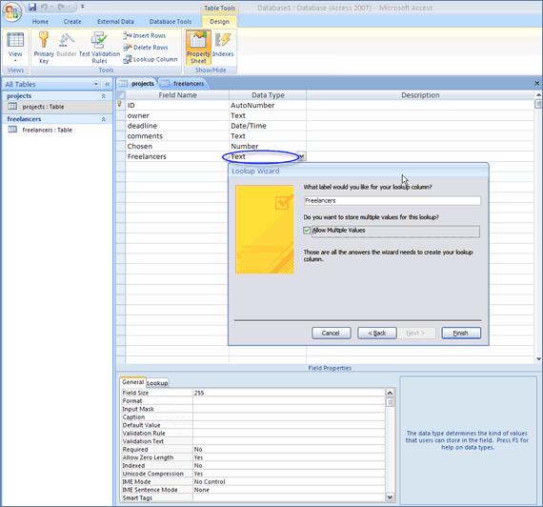  
*Figure 8 Creating a Lookup Column directly from Design View*

If you want to create a lookup field based on the values you enter, first choose "I will type in the values that I want" when the LookUp Wizard opens, then press Next. Now enter the number of columns you need and the values. When finished click Next. When asked "Do you want to store multiple values for this lookup?", select the Allow Multiple Values check box. Then click Finish. The same result can be obtain if you use the Lookup Wizard in Design View.

**Using a Multivalued Field in a Query**

Open the database, then on the Create tab, in the Other group, click on Query Design.

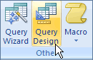  
*Figure 9 Query Design*

In the Show Table dialog box click the table that contains the multivalued field and then click "Add".

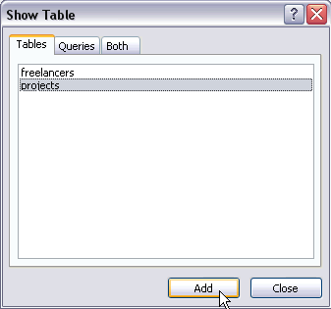  
*Figure 10 Choose the table which contains the multivalued field*

Drag the fields you want to use in the query.

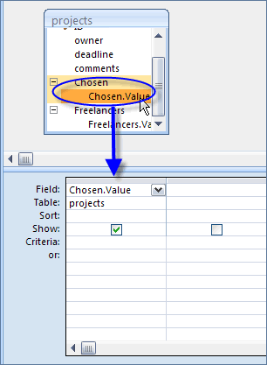  
*Figure 11 Drag the fields in the query*

Now test the query. In the Design tab, the Results Group, click Run.

