## Fugitive Dust Principles and Practices

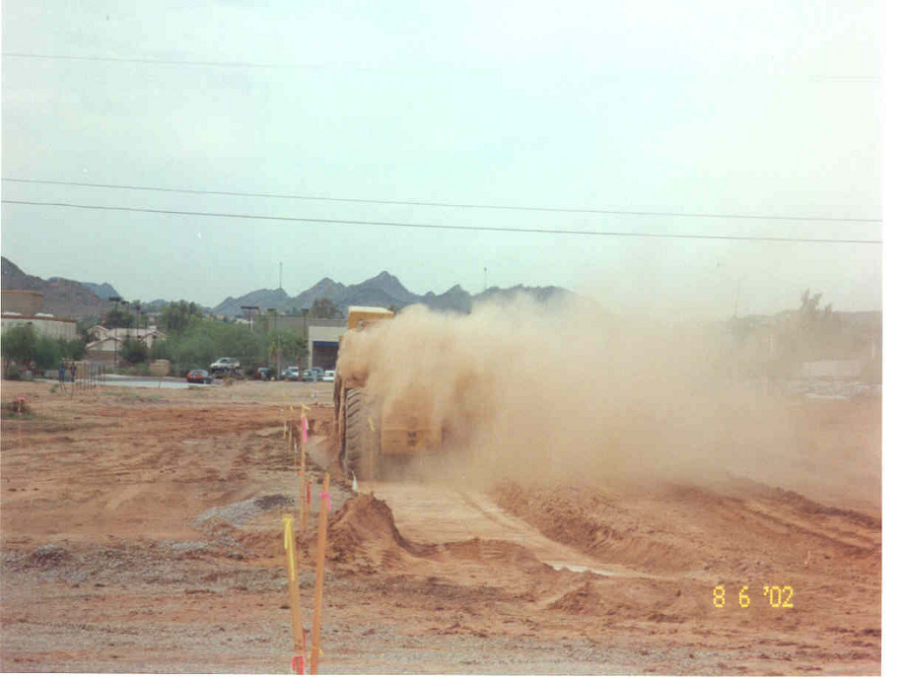

## ONLINE AGENDA

**9:00 am Welcome and Introduction**

**9:15 am Lesson I: Particulate Matter Primer**

**9:45 am Lesson II: Fugitive Dust Overview**

**10:00 am Break**

**10:05 am Lesson III: Rules and Regulations**

**10:20 am Lesson IV: Methods to Determine Violations**

**11:00 am Break**

**11:05 am Lesson IV Continued**

**11:30 am Lesson V: Dust Control Measures**

**12:00 noon Lunch**

**1:00 pm Lesson V Continued**

**1:45 pm Lesson VI: Local Air District Rules**

**2:00 pm Break**

**2:05 pm Lesson VII: Dust Control Plans**

**3:00 pm Break**

**3:05 pm Lesson VII Continued**

**3:45 pm Lesson VIII: Community Outreach**

**4:00 pm Adjourn**