National Air Compliance Training Program

NACT 273
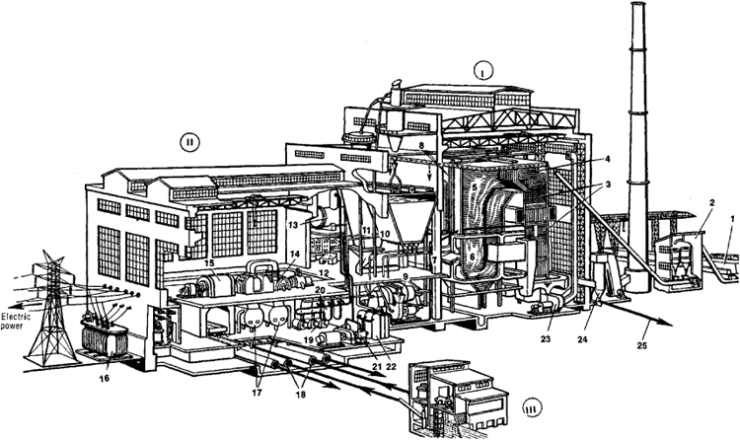
9:00 Introductions, Course Overview, Boiler Uses

9:15 Terminology and Boiler Types

9:30 Theory and Operation of Boilers

10:00 Break

10:10 Boiler Components and Designs

11:00 Emissions and Control Techniques

12:00 Lunch

1:00 Boiler Regulations and Permits

2:00 Break

2:10 Monitoring, Source Testing, Inspections, and Safety

4:00 Adjourn

December 2021

