United States   
Environmental Protection   
Agency

Air

Office of Air Quality   
Planning and Standards

Research Triangle Park, NC27711

EPA 456/R-01-004   
December 2001

oft

o

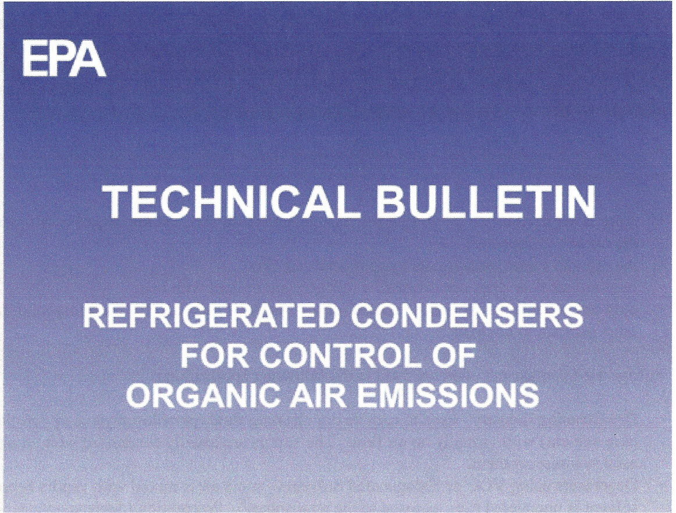

**C LEAN**

**A IR**

**T ECHNOLOGY**

**CENTER**



WHERE CAN YOU USE A REFRIGERATED CONDENSER?

A refrigerated condenser works best on emission streams containing high concentrations of   
volatile organic emissions. They are less effective on dilute streams (i.e., where there is much   
more air flow than organic vapor flow). For example, a paint spray booth requires a substantial   
amount of air flow through it to protect worker health and safety. As a result, most of the heat   
removed by a refrigerated condenser would come from air. The organic vapor content in a paint   
booth emission stream could be recovered by using a refrigerated condenser, but it would be very   
costly per ton of organic compound recovered. In addition, to reuse the organic compound,   
moisture condensation would probably need to be removed.

A refrigerated condenser could be a viable control option for any source of evaporative organic   
emissions if:

* there is minimal air flow carrying the organic emissions (i.e., the air stream is saturated with

the organic compound)

* the organic vapor containment system limits air flow
* required air flow does not overload a refrigeration system with heat
* only one organic compound is emitted (or the system is designed for the compound that is the   
  most difficult to control)

Refrigerated condensers often are used in the following applications:

* Dry Cleaning Industry - used to recycle dry cleaning fluid (perchloroethylene or petroleum-   
  base solvent) with virtually no air flow. The vapors are usually condensed without air being   
  used to transport them.
* Degreasers using VOC or Halogenated Solvents - some air is mixed with vapors because the   
  solvent is uncovered (i.e., exposed to the atmosphere). Preparation (degreasing/cleaning) of   
  parts prior to powder coating is one example of this.
* Transfer of Volatile Organic Liquid (VOL) and Petroleum Products (e.g., bulk plants, bulk   
  terminals, and similar transfer operations).
* Vapors from Storage Vessels/Tanks

WHAT IS REFRIGERATION?

All refrigeration units are basically "heat pumps," absorbing heat on the "cold side" of the system   
and releasing heat on the "hot side" of the system. All refrigeration systems have a hot side and a   
cold side. Some have a compressor. The difference between refrigeration systems is whether the   
refrigerant is actually liquefied within the apparatus and how Iowa temperature the "cold side"   
can reach.

2