Handout 1.A

ENVIRONMENTAL GOALS

# Environmental Quality: These are goals relating to what we think is healthy or safe, e.g., ambient water quality standards for nitrogen, metals; ambient air quality standards.

# Sustain Uses of Natural Resources: For example, soil subsidence, reforestation projects, groundwater clean-up.

# Pollution Prevention: Some examples are reformulation of products so that less waste is produced, recycling of toxic compounds, and waste minimization.

# Acceptable Risk or Risk Reduction: For example, new chemicals must meet lower risk standards before they can be manufactured.

# Equity (Compensation): For example, major users of environmental resources have to pay a tax to compensate for the environmental damage.

# Clean Up Past Contamination: For example, contamination from landfills or leakage of materials from underground storage tanks.

Handout 1.B

EXAMPLES OF ENVIRONMENTAL MANAGEMENT APPROACHES

Voluntary

Public education
Technical Assistance
Awards
(Tax incentives)
(Subsidies)

Regulatory

Establish technology or performance standards
Issue permits or licenses to operate or construct
Require testing of chemicals or wastes
Require monitoring of environmental releases or impacts on the ambient environment
Require reporting of accidents
Require clean up of spills or contamination
Ban practices

Economic/Market-based

Emissions, effluent or waste generation fees
(Tax Incentives)
(Subsidies)
Marketable/tradeable permits
Emission offsets

Liability

Establish responsibility for clean up of contamination
Establish responsibility for payment of victims
Establish responsibility for payment for damages

Handout 1.C

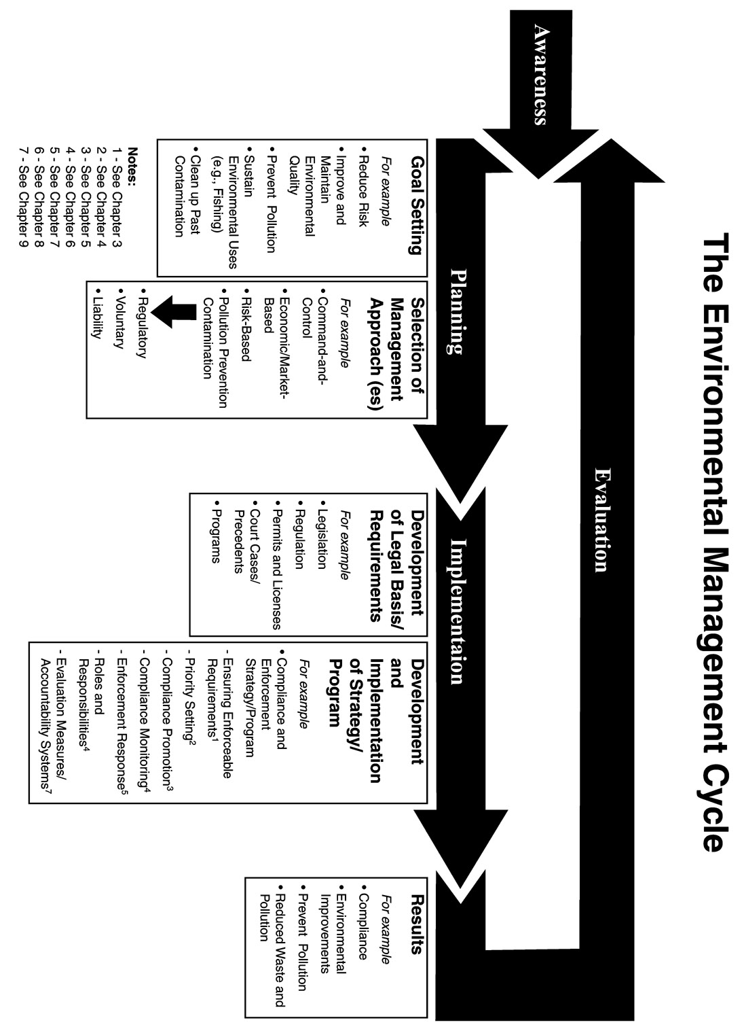
Handout 1.D

Definitions -- Compliance, Enforcement, and Deterrence

Compliance occurs when requirements are met, when desired behaviors are achieved.

For example, that proper pollution control equipment is in place and operating, that production processes or raw materials are changed, that work practices are changed such as disposing of hazardous waste at approved sites, that tests are performed on new products or chemicals before they are used or sold, etc. You must have requirements for compliance to be a concern. In other words, compliance is not a concern where we adopt voluntary approaches to solve environmental problems. If requirements are well designed to achieve sound environmental results, compliance with the requirements will achieve environmental results. If the requirements are poorly designed, enforcement will be difficult and/or the desired results will not be achieved.

Enforcement is the set of actions governments or others take to compel or encourage compliance.

Enforcement actions generally includes inspections to find information needed to determine the compliance status, formal declarations or notices of violations, and legal actions to impose some consequences for violating the law and compel compliance. Programs designed to achieve compliance may involve more than just enforcement, for example they may also include assistance and subsidies.

Deterrence is the creation of an atmosphere in which many people choose to comply rather than violate the law. Four elements are needed to create deterrence:

1- a credible likelihood that a violation will be detected
2- swift and certain response by the government
3- a consequence: appropriate sanction or penalty
4- the perception that the first three conditions exist

All of the elements are interrelated. The more likely it is a violation will be detected, the less critical it is that the penalty be severe in order to create deterrence. The less likely it is that a violation will be detected, the more severe the sanction needed to create deterrence. Deterrence is direct for the violator who is caught and faces some consequence to their action. They should be deterred from violating again. Deterrence is indirect for others who know about the fact that someone's violations were detected and that they received some consequences for their action.

Handout 1.E
PREFERRED REQUIREMENTS
TECHNOLOGY STANDARD
Goal: Reduce BOD (biological oxygen demand) in surface water to an acceptable level by controlling major discharges of municipal waste.
A. No individual who discharges more than x kilograms of BOD per month shall discharge municipal waste to surface water unless such waste stream is first treated in a biological treatment system that reduces from weighted BOD by 94 percent. Compliance is determined by a daily comparison of one hour cumulative testing of the influent and outfall from the system using Test Method 92. | B. Municipal waste shall not be discharged unless the BOD is reduced by the installation of a biological treatment system.
PERFORMANCE STANDARD
Goal: Most power-generating facilities burn coal with 0.9-1.1% sulfur. The national goal is to reduce emissions of SO₂ to the atmosphere by 40%.
A. All operations must reduce the emission of SO₂ by 40 percent. | B. No stack or conveyance shall emit to the atmosphere more than 0.34 kg SO₂ per thousand million joules heat input from any fossil-fuel-fired boiler(s) during any 60-minute period. Compliance shall be determined by Test Method 121 or equivalent method approved by the Director of the Environmental Department.
ECONOMIC REQUIREMENT
Goal: Reduce the generation of hazardous waste.
A. Each generator of hazardous waste listed in Section 123 of the Environmental Department Regulations shall pay an annual fee of $1 per kilogram of waste generated (discharged or emitted, disposed of on site, or hauled off site). The fee and a record of the amount of each listed waste shall be sent to the Environmental Department within 30 days of the end of the calendar year. | B. Each generator of hazardous waste shall pay a fee of $1 per kilogram of waste generated per year. All waste is considered hazardous and must be reported and a fee paid unless the generator demonstrates that the waste does not pose a significant risk to human health or the environment. If fees are not paid for any waste or are late, the generator must pay an additional amount of 50 cents per month.

Handout 1.F

EXAMPLES OF ENVIRONMENTAL
SITUATIONS

A Liquid hazardous waste pond belonging to a factory is next to a public park at which children freely went to play and were subsequently hospitalized.

B Spill of a toxic chemical at a chemical facility which is migrating into groundwater supplies.

C Lead smelter has been exceeding air emission standards for several years and lead emissions have contaminated the surrounding countryside over a 12 kilometer area, an agricultural area producing local food products.

D Prolonged air quality stagnation or drought have made existing requirements ineffective in addressing environmental standards. Public health is in danger.

E Company failed to properly report test results of a pesticide in broad use in agriculture.

HANDOUT 1.G

TYPES OF ENFORCEMENT AUTHORITIES
 | Scenarios
 | A | B | C | D | E
Remedial Actions
1. Authority to impose a schedule for compliance
2. Authority to permanently shut down part of an operation
3. Authority to temporarily shut down certain parts of operations or practices
4. Authority to permanently shut down an entire facility
5. Authority to temporarily shut down an entire facility
6. Authority to deny a permit
7. Authority to revoke a permit
8. Authority to require a facility to clean up part of the environment
9. Emergency powers to enter and correct immediate dangers to the local population or environment
10. Authority to seek compensation for damage caused by the violation
Information
11. Authority to require specific testing and reporting
12. Authority to impose specific labeling requirements
13. Authority to require monitoring and reporting
14. Authority to request information on industrial processes
15. Authority to require specialized training (e.g., in emergency response to spills) for facility employees
16. Authority to require a facility to undergo an environmental audit
Sanctions
17. Authority to impose a monetary penalty with specified amounts per day per violation
18. Authority to seek imprisonment (a jail term)
19. Authority to seek punitive damages or fines within specified limits
20. Authority to seize products
21. Authority to seek reimbursement for government clean-up expenses
22. Authority to bar a facility or company from government loans, guarantees, or contracts
23. Authority to require service or community work to benefit the environment
24. Limitations on financial assistance
Other
25. No enforcement authority necessary
26. Other: _______________________

Handout 1.H

RESPONDING TO VIOLATIONS

INITIAL VIOLATION

A chemical company has a number of processes that have a potential to emit hazardous air pollutants. These emissions can be reduced or eliminated with a set of work practices. Under their Title 5 permit they are required to maintain a logbook indicating when these work practices were conducted. The facility was inspected, and it is found that the company has not maintained the logbook for the last two months. The environmental manager of the facility reported that there had been some rotations of personnel at the facility and the new workers may not have been familiar with the requirement.

SECOND VIOLATION

Six months after the violation was resolved and the case closed an unannounced inspection was conducted of the facility. The inspector found that the logbook was maintained properly for 47 day after the resolution. After that period, it was maintained irregularly and finally there were no entries for the last 27 days

What would you recommend for the initial violation and why?

What would you recommend for the second violation and why?

A. Telephone call
B. Increase Inspections
C. Warning letter
D. Official notice of violation
E. Negotiation of compliance schedule
F. Close down part of the operation temporarily
G. Close down part of the operation permanently
H. Close down the whole operation temporarily
I. Close down the whole operation permanently
J. Revoke their permit
K. Order that the company correct the problem
L. Require increased monitoring and reporting
M. Fines (i.e., a fixed amount not influenced by variables such as duration or seriousness of violation)
N. Penalty (i.e., a calculated amount influenced by one or more variables such as duration and seriousness of the violation)
O. File a civil case with the court
P. Seek criminal penalties or jail term
Q. Seizure of property
R. Denial of government funding or assistance
S. Negative publicity
T. No response
U. Other:________________________________________________

Handout 1.I

COMPONENTS OF AN
ENFORCEMENT PROGRAM

1. Creating requirements that are enforceable.

2. Knowing who is subject to the requirements and setting program priorities.

3. Promoting compliance in the regulated community.

4. Monitoring compliance.

5. Responding to violations.

6. Clarifying roles and responsibilities.

7. Evaluating the success of the program and holding program personnel accountable for its success.

Handout 1J

COALLAND CASE STUDY

BACKGROUND

You live in Coalland (see map). As in many countries, both the population and industrial activity have increased over the years. With these increases came several environmental problems. The rivers became polluted with municipal, industrial, and agricultural wastes. The air became polluted with sulfur dioxide and many other emissions from industrial, residential, and transportation sources. In some places the soil became contaminated from deposition of air pollutants and from waste materials and runoff. Improper disposal of wastes has contaminated the ground and surface waters in some areas. This in turn has introduced contaminants in drinking water. Open waste sites and contaminated surface waters also pose a threat to public health. As these pollution problems became more visible, the people of Coalland became increasingly concerned. They pressured the government to create an environmental department that would help solve these problems. In subsequent elections, they elected the Greener Party because this Party promised to address Coalland's environmental problems.

The Party immediately established an Environmental Department. The Department commissioned a risk-based assessment of the environmental problems in Coalland. The study showed that several problems pose significant risks to public health and/or the environment. One of these problems is the level of sulfur dioxide in the ambient air of Coalland's three cities. The Director of the Environmental Department established several expert teams to tackle these major problems. He heard that you have environmental expertise and asked you to join the new Sulfur Dioxide Team to determine the best solution to the sulfur dioxide problem.

First the Sulfur Dioxide Team asks if air monitoring data are available to identify the cause of the problem. Some monitoring data are available and this show that the problem is sulfur dioxide emitted when power plants burn coal for energy and when residents burn coal in their homes for heating. The power plants burn coal all year. Residents burn coal only during cold months (October to April). A little less than half of the coal that is produced is used in west and south Coalland. This coal has a high sulfur content (2.5%) and produces sulfur dioxide when burned. The rest of the coal is currently produced and used in northeast Coalland. This coal has a very low sulfur content (0.8%). When burned, it produces lower quantities of sulfur dioxide than high-sulfur coal. The amount of sulfur dioxide produced is directly related to the sulfur content of the coal.

The one major city in west Coalland, Peopleville, is located in the Scenic River Valley between the Peak Mountain ranges. Coal mined in these mountains has a sulfur content of 2.5%. There are two power plants located 10 and 20 kilometers up the river from Peopleville. The area is known for its winter inversions, in which air is trapped and concentrations of pollutants build up.

The one major city in southern Coalland is Plainsville. This city is located at the
confluence where the Flat River joins the Scenic River. The terrain is generally agricultural flat land. One small power plant is located in the city. Both residents and the power plant use the high sulfur coal from the Peak Mountains.

Mountainview is a mining city in northeast Coalland located between the Flat and Small Rivers in the foothills of the High Mountains. Three large power plants are located near this city. The trees in the High Mountains are harvested and recently have shown signs of acid rain impact on their growth.

All residences in Coalland are heated by coal-fired units. The sulfur dioxide in the air varies based on emissions from power plants and home heating; heights of the power plant stacks; geographic terrain; and weather stagnations.

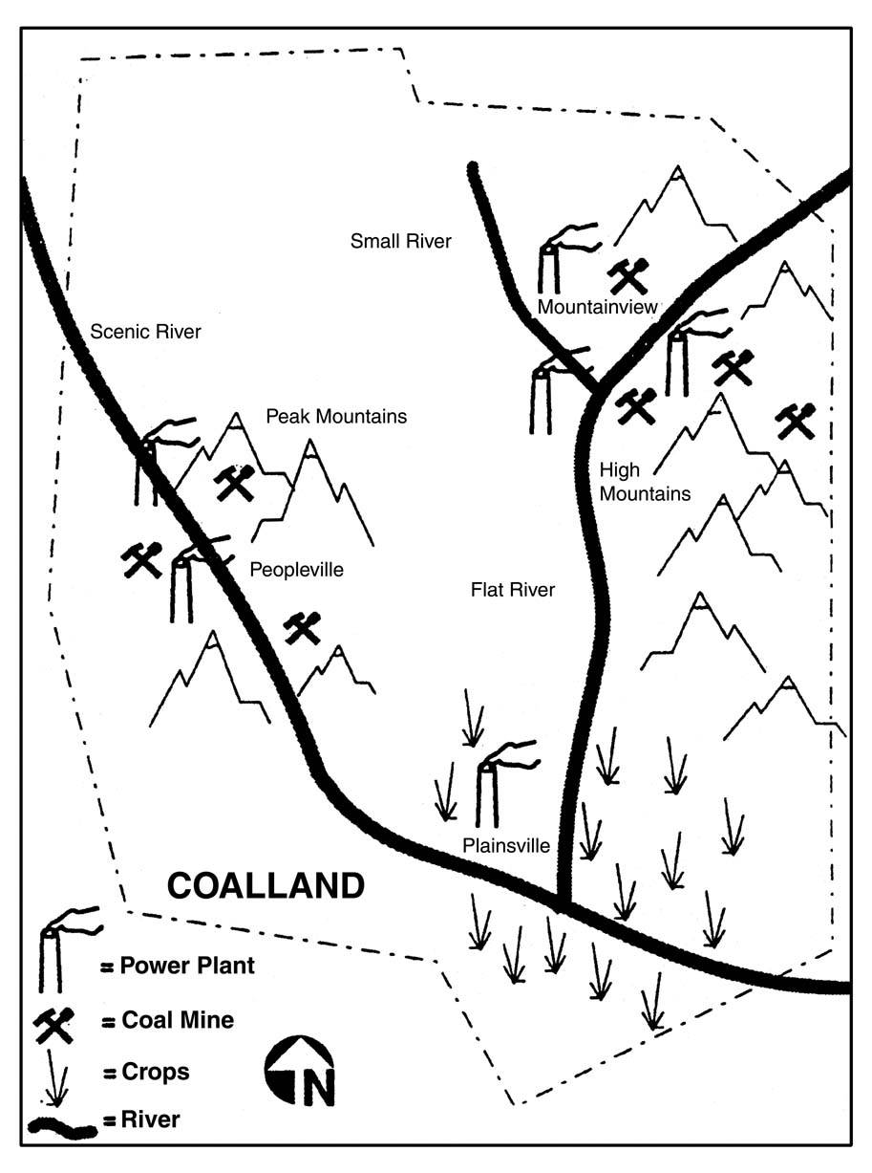
On the recommendation of the Sulfur Dioxide Team, the Environmental Department establishes three monitoring stations in the three major cities and adopts an Ambient Standard of 1 to Protect Human Health. The Sulfur Dioxide Team recommends that an environmental program be instituted to ensure that the sulfur dioxide in ambient air does not exceed this standard. One year of air monitoring provides the following information about the ambient air quality in the three cities relative to the standard:

Average Ambient Sulfur Dioxide Level Relative to the Health Standard
(Standard = 1)
City | Winter | Summer
Peopleville  Plainsville  Mountainview | 2.8  2.1  1.2 | 1.4  0.7  0.8

The Sulfur Dioxide Team asks for a study to identify the possible communities that could help improve air quality. The study shows three possible groups: coal producers, power plants, and local residents. The study provides the following information about these groups:

# Power Plants. All power plants burn the same amount of coal. The two power plants in Peopleville and one power plant in Plainsville currently burn high sulfur coal. The three power plants in Mountainview burn low sulfur coal.

# Coal Producers. All seven coal mines produce the same amount of coal.

# Residents. There are 200,000 residences in Coalland, all of whom burn coal for heating. Approximately 100,000 residences are located in Mountainview. Peopleville and Plainsville have approximately 50,000 residences each. All of the residences in Peopleville and Plainsville burn high sulfur coal; all of the residences in Mountainview burn low sulfur coal.

 | Number | High Sulfur  Coal Use | Low Sulfur  Coal Use
Power Plants | 6 | 3 | 3
Coal Producers | 7 | 3 | 4
Residents | 200,000 | 100,000  (50,000 Peopleville  50,000 Plainsville) | 100,000  (Mountainview)

The air emissions monitoring data indicate that, in the winter, residential burning of coal accounts for 50% of the coal use in Peopleville, 33% of the coal use in Mountainview, and 67% of the coal use in Plainsville. In the summer, all coal use can be attributed to the Power Plants.

SUMMER SO₂ LEVELS

 | Power Plants |  |  | Residents
 | Number | % Contri- bution to Total SO₂ Emissions in Coalland | % Contri- bution to Local (City-wide) Ambient SO₂ | Number | % Contribution to Total SO₂ Emissions in Coalland | % Contri- bution to Local (City-wide) Ambient SO₂
People-  ville | 2 | 50% | 100% | 50,000 | 0% | 0%
Plains-  ville | 1 | 25% | 100% | 50,000 | 0% | 0%
Mountain-  view | 3 | 25% | 100% | 100,000 | 0% | 0%

WINTER SO₂ LEVELS

 | Power Plants |  |  | Residents
 | Number | % Contri- bution to Total SO₂ Emissions in Coalland | % Contri- bution to Local (City-wide) Ambient SO₂ | Number | % Contribution to Total SO₂ Emissions in Coalland | % Contri- bution to Local (City-wide) Ambient SO₂
People-  ville | 2 | 30% | 50% | 50,000 | 15% | 50%
Plains-  ville | 1 | 15% | 33% | 50,000 | 15% | 67%
Mountain-  view | 3 | 15% | 67% | 100,000 | 10% | 33%

DEVELOPING APPROACHES

The Sulfur Dioxide Team then considers the possible technological, economic, and other approaches the government could implement to achieve the recommended goal of ambient sulfur dioxide levels that do not threaten human health. An initial study identifies several management approaches (see Table 1). The study also provides the following information on technologies for coal washing and SO₂ emissions control.

Coal Preparation
# Standard Coal Washing. This technology removes sulfur from coal. Coal is prepared by grinding it up into pieces and submerging it in a solution of water and magnetite. The coal, which is less dense than the solution, floats to the top. The ash, which is more dense than the solution, floats to the bottom. Depending on the specific coal characteristics and the type of preparation procedure, standard coal washing can result in a 0-25% reduction of sulfur dioxide emissions when the washed coal is burned. Higher removal percentages can be achieved with high-sulfur coal than with low-sulfur coal. Costs range from less than zero to about $200/metric ton SO₂ removed. Capital requirements are relatively low.
# Advanced Coal Washing. This technique is similar to standard coal washing, except that a centrifuge is created which removes an even higher amount of ash. Advanced coal preparation results in a 25-60% reduction in sulfur dioxide emissions when the washed coal is burned. Higher removal percentages can be achieved with high-sulfur coal than with low-sulfur coal. Advanced coal washing costs about $300-$1,000/metric ton SO₂ removed. Capital costs are moderate.

Control Technologies
# Wet Limestone Scrubbing. This technology removes sulfur dioxide by creating a chemical reaction between a catalytic reagent (usually lime or limestone) and sulfur in the flue gas stream. The sulfur particulates are then subjected to an electric field, charged, and removed from the flue gas stream. The cost varies depending on the specific technology, coal characteristics, and site characteristics. Costs range from $300-$500/metric ton SO₂ removed. Removal efficiencies range from 90-95%. The capital requirements are significant. This technology would be cost-effective only for electric power plants and large industrial sources.

# Dry Sorbent Injection. This technology works in a similar way to wet limestone scrubbing but is less efficient. Depending on the specific technology, coal characteristics, and site characteristics, removal efficiencies range from 50-80% and costs range from $200-$300/metric ton SO₂ removed. Capital requirements are moderate. This technology would be cost-effective only for electric power plants and large industrial sources.

TABLE 1. MATRIX OF SULFUR DIOXIDE MANAGEMENT ALTERNATIVES

Approach | Regulated  Group | SO₂ Removal | _{Cost ($/Ton}  _{SO2} Removed) | _{Implementability} | _{Other Concerns}
_{TECHNOLOGICAL}
_{A.} Require coal washing to remove sulfur. | _{Coal}  _{Producers}  _{and/or}  _{Power}  _{Plants} | _{a.} _{Standard coal washing:}  _{0-25% SO2} reduced.  b. Advanced coal washing:  25-60% SO₂ reduced. | a. $200/metric ton SO₂ removed.  b. $300-$1,000/metric ton SO₂ removed. | Proven available technology. | Ash disposal.  Increased coal prices.
B. Require power plants to control sulfur dioxide emissions. | Power  Plants | a. Wet limestone scrubbing:  90-95% SO₂ removal.  b. Dry sorbent injection:  50-80% SO₂ removal. | a. $300-$500/metric ton SO₂ removed.  b. $200-$300/ton SO₂ removed. | Proven available technology. | Increased power prices.  Ash disposal.  Sludge disposal.
C. Require coal users to convert to another form of energy. | Power  Plants  and/or  Residents | 100% SO₂ removal. | Long-term cost savings (due to the relatively high cost of mining coal). | Natural gas is available in Coalland. | Unemployed miners.  Raising the initial capital funds for conversion may be difficult.

PERFORMANCE-BASED
D. Require that sulfur dioxide emissions from coal burning not exceed a certain level. | Power  Plants | Everything above the regulated level. | Depends on difference between current and required emission level and on the means used to reduce SO₂ emissions (see A, B, C). | Technologies are available. | Cost may be passed on to consumers.
E. Require that sulfur dioxide emissions be reduced by X%. | Power  Plants | X% | Depends on means used to reduce SO₂ emissions. | Technologies available. | Costs of SO₂ reduction may be passed on to the consumer. Could be economically inefficient. All power plants - even those with low emissions - would have to make changes.
ECONOMIC
F. Charge a sulfur dioxide emission tax. | Power  Plants | Will vary depending on tax level. The higher the tax, the greater will be the economic pressure on power plants to reduce their SO₂ emissions. | Will vary depending on which approach power plants use to reduce their SO₂ emissions (see A,B,C). | Requires knowledge of SO₂ emission levels as basis for tax. Technologies that could be used to reduce SO₂ emissions are available (see A,B,C). | The success of this approach in improving air quality is unpredictable (see also A,B,C).  Power plants will raise the cost of coal to pay for the tax and/or cost of reducing SO₂ emissions. Coal production will be affected if power plants switch to alternative fuels or low-sulfur coal.
G. Use tax incentives to encourage coal users to reduce sulfur dioxide emissions through prevention or control. | Power  Plants  and/or  Residents | Will vary depending on response to tax incentives. High incentives may encourage users to take steps to reduce or prevent SO₂ emissions. | The cost to consumers will be lower than an approach that does not provide an incentive or a subsidy. | Depends on availability and cost of technologies for reducing or preventing SO₂ emissions. | Unless taxes are sufficiently high, users may not be stimulated to reduce or prevent SO₂ emissions unless they have personal or professional concerns about SO₂ levels.
H. Develop emission rights that can be traded. | Power  Plants | Depends on the underlying basis for the emission rights (see D and E). See also "Other Concerns." | Cost will likely be less than approaches A, B, C, D, or E because this option provides greater flexibility. | See D and E. | The reduction in sulfur dioxide levels in ambient air may vary at the local level depending on the extent of the area in which emission rights can be traded. The larger area, the greater the potential for variability. (See also D and E.)
I. Tax high-sulfur coal. | Coal  Producers  and/or  Power  Plants  and/or  Residents | Depends on how coal users respond to the tax. SO₂ removal will be proportional to number of users that stop using high-sulfur coal. | See C. | Depends in part on availability of low-sulfur coal and alternative fuels. | See C. May reduce demand for high sulfur coal, leading to unemployment in Peopleville.
J. Government subsidies. | Power  Plants  and/or  Residents | Depends on motivation of coal users to take advantage of subsidies. | Cost to the user will be less then a comparable unsubsidized approach. This cost difference will be borne by the government. | (See A,B,C). | Depends on what is being subsidized (see A, B, C).

VOLUNTARY APPROACHES
K. Educate coal users about the health effects of sulfur dioxide pollution and about ways to reduce their high-sulfur coal use. | Power  Plants  and/or  Residents | Depends on the effectiveness of the education in raising people's consciousness. | Minimal. | Easily implemented. | May generate a heightened awareness of SO₂ problems but may not produce a quantitative change in SO₂ emissions.
L. Provide technical assistance. | Coal  Producers  and/or  Power  Plants | Depends on the technology utilized. | Depends on the technology utilized. | Depends on the technology. | The percent reduction in SO₂ emissions will vary with the technology selected.
M. Promote conservation. | Power  Plants  and/or  Residents | Depends on the effectiveness in raising people's consciousness. | Minimal. | Easily implemented. | May generate a heightened awareness of SO₂ problem but does not guarantee a specific level of SO₂ reduction.
OTHER APPROACHES
N. Prohibit use of high-sulfur coal. | Power  Plants  and/or  Residents | Virtually 100% | If low-sulfur coal is used, coal prices may increase due to increased demand and transportation costs.  If users convert to natural gas, there may be long-term cost savings (see C). | Low-sulfur coal and natural gas are available. | Residents in Peopleville and Mountainview will import low sulfur or switch to natural gas. Politically, this may not be feasible.
1Monetary units are given in U.S. currency.

